
Innovation idea submission portal
REQUIREMENT DOCUMENT

Prepared by: Digital innovation workunit
June 29, 2026
.
- Introduction
Innovation and continuous idea generation play an important role in helping banks improve operational efficiency, enhance customer experience, strengthen competitiveness, reduce operational challenges, and support digital transformation initiatives. Encouraging employees to contribute innovative ideas enables the organization to identify improvement opportunities, introduce new services, optimize internal processes, and foster a culture of innovation across the bank.
To support this objective, the bank has established an internal idea submission portal that allows employees to submit innovation ideas and enables evaluators to review and assess submitted ideas. The portal primarily serves as a platform for collecting and evaluating innovative ideas contributed by employees across different business and operational areas.
While the existing portal supports basic idea submission and evaluation processes, several activities still require manual coordination and follow-up outside the system. In addition, the current platform lacks enhanced functionalities required to support a more streamlined, transparent, automated, and user-friendly process.
As part of the bank’s ongoing innovation and digital transformation initiatives, the bank intends to enhance and redevelop the existing portal into a more comprehensive and fully system-driven Innovation Idea Submission and Evaluation Platform.
The enhanced portal is expected to:
- Improve employee engagement and participation in innovation initiatives
- Simplify and digitize the idea submission and evaluation process
- Support both competition-based and continuous/open idea submissions
- Enable structured evaluation workflows
- Support internal and external hackathon activities
- Facilitate collaboration and discussion around submitted ideas
- Improve transparency and idea status tracking
- Provide notifications, dashboards, and reporting capabilities
- Reduce manual intervention
The proposed solution will serve as a centralized digital platform for collecting, reviewing, evaluating, and tracking innovation ideas submitted by employees and other authorized participants through a structured and transparent process.
This Business Requirements Document (BRD) outlines the business, functional, and non-functional requirements for enhancing and redeveloping the existing Innovation Idea Submission and Evaluation Portal and will serve as a reference document during engagement, solution evaluation, development, and implementation activities.
- Purpose of the Document
The purpose of this document is to define the business, functional, and non-functional requirements for enhancing and redeveloping the existing Innovation Idea Submission and Evaluation Portal.
This document serves as a reference for developers to:
- Understand the bank’s business needs and expectations
- Propose suitable technical solutions and system architecture
- Estimate implementation approach, timelines, and resource requirements
- Identify integration, security, and scalability considerations
- Support solution evaluation and vendor selection processes
The document also aims to ensure that the proposed solution aligns with the bank’s innovation initiatives, operational requirements, and digital transformation objectives.
- Business Objectives
- Encourage continuous innovation across the bank
- Increase employee participation in idea submission initiatives
- Improve transparency in the idea evaluation process
- Digitize and automate idea submission and evaluation workflows
- Reduce manual coordination
- Support innovation competitions and hackathons
- Improve tracking and reporting of submitted ideas
- Enhance collaboration and feedback mechanisms
- Create a centralized repository of innovation ideas
- Current System Challenges
- Limited automation in evaluation and workflow processes
- Manual follow-up and communication outside the system
- Limited tracking and visibility of idea status
- Lack of collaboration and discussion features
- Limited reporting and dashboard capabilities (filtering options)
- No structured hackathon or campaign management functionality
- Limited notification and reminder mechanisms
- User experience and interface improvement is needed
- Limited scalability for future enhancement requirements
- Some users were not able to track their ideas on the system since it was not linked with latest HR system
- Functional Requirement
The proposed solution involves enhancing and redeveloping the existing Innovation Idea Submission and Evaluation Portal into a more comprehensive, automated, and user-friendly platform that supports end-to-end digital processes for idea collection, evaluation, collaboration, and innovation campaign activities.
The scope of the solution includes the following components:

Idea Submission
The system shall support:
- Competition-based idea submissions within defined timelines
- Continuous/open idea submissions without time restrictions
- Submission of ideas by internal employees
- Submission of ideas by external/public participants for hackathons where applicable
- Draft saving and later submission functionality
- Attachment uploads including documents, presentations, images, and short videos
The system should capture the below mandatory fields:
- Idea title -
- Problem statement -
- Proposed solution
- Expected business value
- Supporting documents and media files - 100MB Max
- Idea category and theme
- Strategic pillar –
- Remark

Idea Evaluation
The system shall support:
- Structured evaluation workflows
- Multi-level evaluation processes with configurable fields like;
  - Screening size
  - Evaluators
  - Evaluation phases
  - Evaluation rubric
- Evaluation by:
  - Pre-screening by portal admins
  - Phase one screening by Senior Managers
  - Phase two screening by Department Directors
  - Final phase evaluation by Chiefs
  - Assigned judges or evaluators (if applicable)
- Scoring and ranking mechanisms based on predefined criteria
- Evaluation comments and feedback
- Automatic forwarding of ideas to relevant departments where applicable

Innovation Campaign & Competition Management
The system shall support:
- Creation and management of innovation campaigns
- Competition setup, criteria and competition rule configuration
  - E.g. Pre-screening criteria’s
    - The system should be able to drop if the ideas is in STMS
    - Incomplete submissions
- Submission opening and closing date management
- Deadline setting and extension by toggle
- Countdown timers for active competitions
- Category and theme-based competitions
  - Idea category and theme
    - Incremental Innovation: Improving what already exists -a better feature, a faster process, a lower cost.
    - Disruptive Innovation: A new approach that redefines the market or displaces existing solutions entirely.
    - Product Innovation: New or significantly improved financial products, digital features, or customer-facing services.
    - Process Innovation: New ways of delivering or managing services -automation, workflow redesign, faster approvals.
    - Service Innovation: Changing the customer experience without necessarily changing the core product -personalisations, Omni - channel, proactive support.
    - Channel Innovation; Introducing or improving delivery pathways - SuperApp, USSD, agent networks, open banking APIs.
    - Marketing Innovation: New ways to position, communicate, and acquire customers for existing or new products.
  - Strategic pillar:
    - Increase Market share
    - Decrease cost-to-income ratio
    - Enhance Customer Satisfaction
- Reward and recognition setup
- Announcement and notification capabilities

Hackathon Support
The system shall support:
- Internal and external hackathon participation
- Online and in-person hackathon events
- Hackathon registration and submission management
- Countdown and deadline notifications by toggle.
- Pitch session support
- Audience voting and evaluation support where applicable

Collaboration & Discussion
The system shall provide:
- Discussion forums
- Commenting capabilities
- Feedback mechanisms
- Collaboration opportunities between participants and reviewers
- Idea discussion threads
- Blog and post creation

Idea Tracking & Notifications
The system shall allow users to:
- Track submitted idea status in real time
- Receive notifications and updates regarding:
  - Submission confirmations
  - Evaluation progress
  - Feedback responses
  - Pending evaluation reminders
  - Competition announcements
  - Deadline reminders
  - Feedback notifications
  - Hackathon announcements
  - Final evaluation results
  - Hackathon updates and schedules
- Notifications should be supported through:
  - In-system notifications
  - Email notifications
  - SMS notifications where applicable
Possible idea statuses may include:

Phase 1: Submission & Intake
- Draft: In Progress or Draft
- Submitted: Submitted or Received

Phase 2: Initial Eligibility (Pre-Screening)
- Pre-screening: Eligibility Check or Initial Screening - Check if the idea submitted is duplicate or exist in STMS.
- Rejected/Approved: Disqualified / Qualified (or Declined / Accepted for Review)

Phase 3: Formal Evaluation & Selection
- Under Review: Evaluation Panel or Under Evaluation
- Shortlisted /Rejected: Finalist / Not Selected

Phase 4: Finalization & Implementation
- Ranked List: Leaderboard or Final Standings (or Winners Announced)
- Implemented: In Development or Realized (or Executed)

Dashboard & Reporting
The system shall provide dashboards and reports for:
- Filtered report capability based on idea statuses
- Submitted ideas
- Evaluation progress
- Participation statistics
- Competition performance
- Department-level innovation statistics
- Hackathon participation metrics
- User engagement statistics
- Final ranking shall be visible on admin page along with winner’s user name and detail
Reports should support export functionality in formats such as:
- PDF, Doc
- Excel

User Roles & Access Levels
The system shall support role-based access control with different permissions and responsibilities.
Role | Responsibilities
Employee/Internal User | Create, delete, view and edit ideas  Track status of their idea  Discuss and collaborate on ideas  Give feedback when applicable  Participate in forums and hackathons.  Receive milestone notification
External/Public User  (in case of hackathon) | Submit ideas where permitted  Receive milestone notification
Evaluator/Judge | Review and evaluate submitted ideas  Give feedback if any
Innovation Team/Admin | Create campaigns/ competitions and management  Push notifications  Add evaluators to the portal  Add evaluation criteria’s and rules for competition campaign  Create forums and hackathons  View submitted ideas  Manage portal users

- Other Technical Requirements

User Management
The system shall:
- Support secure user authentication
- Support role-based authorization
- Allow user profile management
- Integrate with internal user directory services where applicable
- Evaluator role should be given by admin rather than cyber team

Submission Management
The system shall:
- Allow users to create, edit, view and submit ideas
- Support draft saving functionality
- Allow attachment uploads
- Allow video uploads for idea pitching
- Validate mandatory fields before submission

Workflow Automation
The system shall:
- Automate routing of submitted ideas
- Support configurable workflows
- Trigger notifications automatically
- Allow workflow status tracking

Evaluation Management
The system shall:
- Support configurable evaluation criteria
- Allow evaluators to score submissions
- Support comments and recommendations
- Generate ranking and scoring summaries

Notification Management
The system shall:
- Send email and system notifications
- Provide reminders for deadlines and pending evaluations
- Notify users of status changes and feedback

Search & Filtering
The system shall:
- Allow searching of submitted ideas
- Support filtering by:
  - Category
  - Status
  - Department
  - Submission period
  - Competition type

- Non-Functional Requirements

Security
The system shall:
- Implement secure authentication mechanisms
- Support role-based access control
- Protect confidential information and uploaded files
- Maintain audit logs of user activities

Performance
The system should:
- Provide fast response times
- Handle concurrent users efficiently
- Support large attachment uploads

Scalability
The system should:
- Support future enhancements and integrations
- Handle increasing user and submission volumes
Considering the sensitivity of internal innovation data and employee submissions, the system should implement strong security controls and compliance measures.
The solution should support:
- Secure login and authentication mechanisms
- Role-based access control
- Data encryption during transmission and storage
- Secure file upload and storage
- Audit trail and activity logging
- Session timeout and password policies
- User activity monitoring
- Backup and disaster recovery capabilities
The vendor should also explain the proposed security architecture and compliance standards followed during development and deployment.

Usability
The system should:
- Be user-friendly and intuitive
- Support responsive web access
- Provide simple and easy navigation

Availability
The system should:
- Ensure high system availability
- Support backup and recovery mechanisms
- Integration Requirements
The proposed solution should support integration capabilities with existing internal and external systems where applicable.
Possible integrations may include:
- Internal authentication systems
- Email and notification systems
- Internal portals or collaboration platforms
- Reporting and analytics tools
- Document management systems
The developers should clearly specify:
- Supported integration methods
- API Integration capabilities
- Security standards
- Integration architecture and dependencies
- Integration documentation
- Assumptions and Constraints
This project assumes that:
- Existing infrastructure and hosting environments will be available where necessary
- Required stakeholders will participate during requirement clarification and testing phases
- Internal users will have access to required authentication systems
Potential constraints may include:
- Budget limitations
- Timeline constraints
- Integration dependencies
- Existing infrastructure limitations
- Regulatory or security compliance requirements
- Success Criteria
The success of the proposed solution will be measured based on:
- Enhance user experience through interactive UI
- Increased employee participation in innovation competition
- Reduced manual processes and administrative workload
- Improved transparency in idea evaluation and tracking
- Faster automated evaluation turnaround time
- Improved user satisfaction and engagement
- Increased visibility into innovation activities and outcomes
- Successful execution of competitions and hackathons through the platform

Appendix A – High-Level Workflow Diagram

Competition-Based Idea Submission Workflow
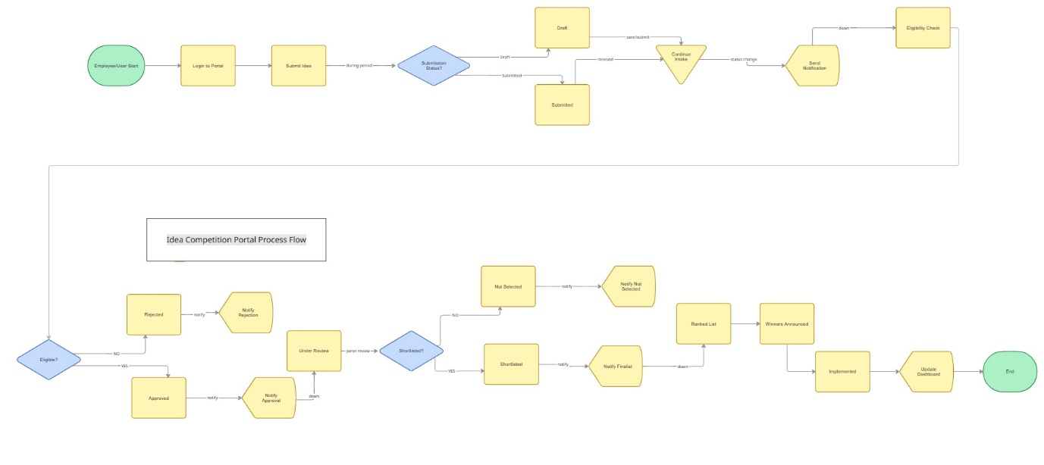Employee/User

Hackathon Workflow
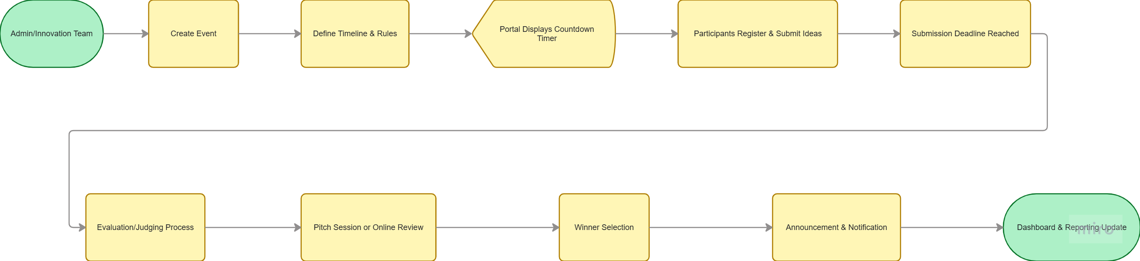

Idea Evaluation Workflow
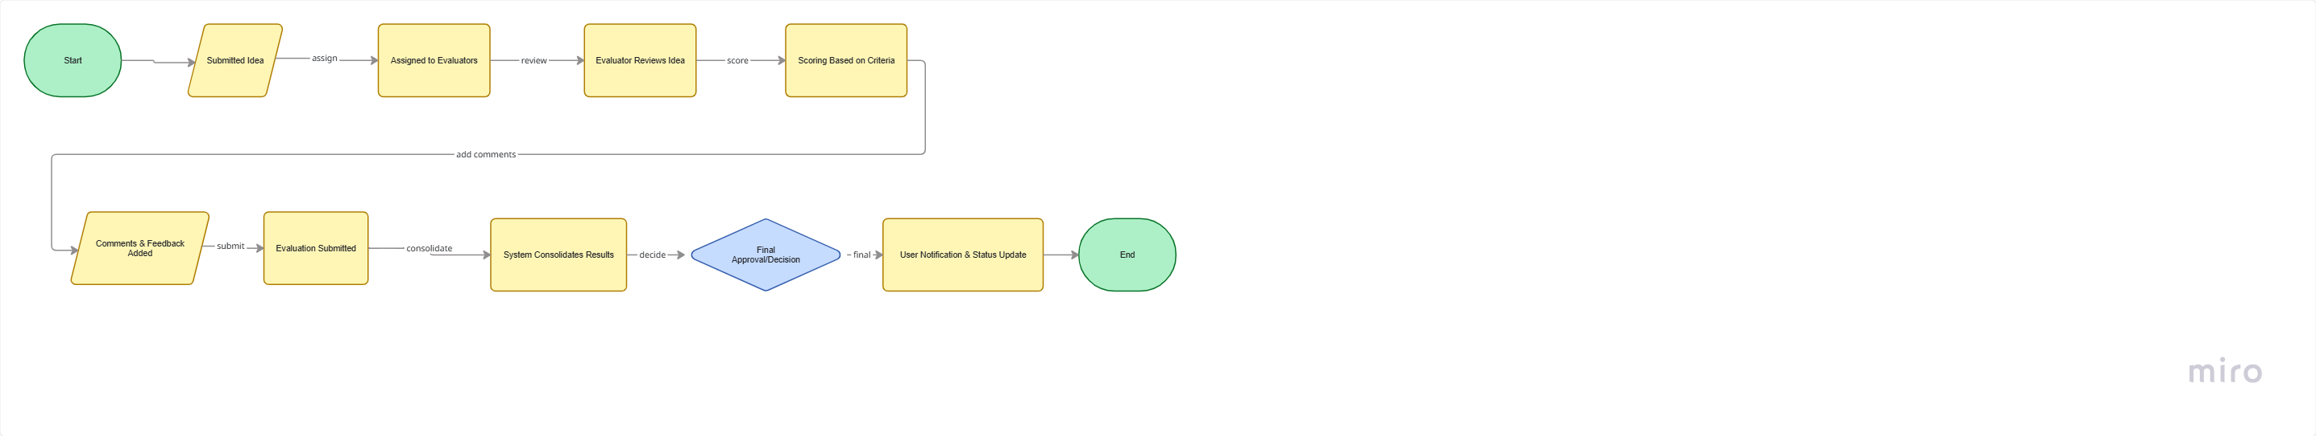

Appendix B – Mock-up References
The following mock-up references are intended to provide vendors with a high-level understanding of the expected user interface structure, user experience expectations, and major functional screens of the proposed Innovation Idea Submission and Evaluation Portal. These references are conceptual and may be further refined during the design and requirement validation phase.

Landing Page
- Login & Sign-Up: Provides secure user authentication and registration functionality, allowing users to create profiles and access personalized dashboards or event portals.
- News & Ads (Competitions/Hackathons): A dynamic promotional section to broadcast upcoming events, registration deadlines, rules, and sponsor advertisements to drive user engagement.
- Contact Us Options: Features a support communication channel (e.g., contact form, email links, FAQs) for users to submit inquiries and receive administrative assistance.
- Social Media Links: External links to official social profiles and community channels (e.g., LinkedIn, Discord, GitHub) to foster community building and real-time collaboration.
- Gallery: A visual repository of photos, videos, and winning project highlights from past events to serve as social proof and user inspiration.
- Organization branding and portal banner
- Testimonials / Innovation Success Stories

Home Dashboard

Expected Components
- List of active competitions and hackathons
- Countdown timers for active campaigns
- Recent announcements
- Competition, submission, evaluation - guideline and requirement
- User activity summary
- Notifications panel
- Idea status overview
- Forum page
- Quick navigation menu
- FAQ
- Contact support

Idea Submission Page

Expected Components
- Idea title field
- Problem statement section
- Proposed solution section
- Expected business value section
- Category and theme selection
- Strategic pillar selection option
- File upload option
- Remark option
- Save draft functionality
- Submit button

My Ideas Page

Expected Components
- Submitted idea list
- Submission date
- Current status
- Competition/campaign category
- Edit draft option
- View feedback/comments
- Search and filtering functionality

Evaluation Dashboard

Expected Components
- Assigned ideas list
- Evaluation criteria and scoring form
- Comment and feedback section
- Ranking and scoring summary
- Evaluation status indicators

Competition & Hackathon Management Page

Expected Components
- Competition creation form
- Submission opening and closing dates configuration
- Countdown timer configuration
- Participant management
- Announcement management
- Event status tracking
- Evaluation assignment options
- Evaluation criteria and point/mark configuration
- Option to Posting number of shortlisted ideas to the next stage

Discussion & Collaboration Forum

Expected Components
- Create forum topic
- Discussion threads
- Comment section
- Reply and interaction options
- Idea collaboration discussions
- Moderation controls for administrators

Notifications Page

Expected Components
- Notification list
- Read/unread indicators
- System alerts
- Deadline reminders
- Evaluation feedback notifications

Reports & Analytics Dashboard

Expected Components
- Submission statistics
- Evaluation progress metrics
- Department participation analysis
- Graphical dashboards and charts
- Export to PDF/Excel functionality

